## **Project 01 - 1 Hour**

## **Deploying a Scalable Web Application with Persistent Storage and Advanced Automation**

### **Objective:**

Deploy a scalable web application using Docker Swarm and Kubernetes, ensuring data persistence using a single shared volume, and automate the process using advanced shell scripting.

### **Overview:**

1. **Step 1**: Set up Docker Swarm and create a service.
2. **Step 2**: Set up Kubernetes using Minikube.
3. **Step 3**: Deploy a web application using Docker Compose.
4. **Step 4**: Use a single shared volume across multiple containers.
5. **Step 5**: Automate the entire process using advanced shell scripting.

### 

#### 

### 

### **Project 02 - 1 Hour**

### **Comprehensive Deployment of a Multi-Tier Application with CI/CD Pipeline**

### **Objective:**

Deploy a multi-tier application (frontend, backend, and database) using Docker Swarm and Kubernetes, ensuring data persistence using a single shared volume across multiple containers, and automating the entire process using advanced shell scripting and CI/CD pipelines.

### **Overview:**

1. **Step 1**: Set up Docker Swarm and create a multi-tier service.
2. **Step 2**: Set up Kubernetes using Minikube.
3. **Step 3**: Deploy a multi-tier application using Docker Compose.
4. **Step 4**: Use a single shared volume across multiple containers.
5. **Step 5**: Automate the deployment process using advanced shell scripting.

### **Step 1: Set up Docker Swarm and Create a Multi-Tier Service**

#### **1.1 Initialize Docker Swarm**

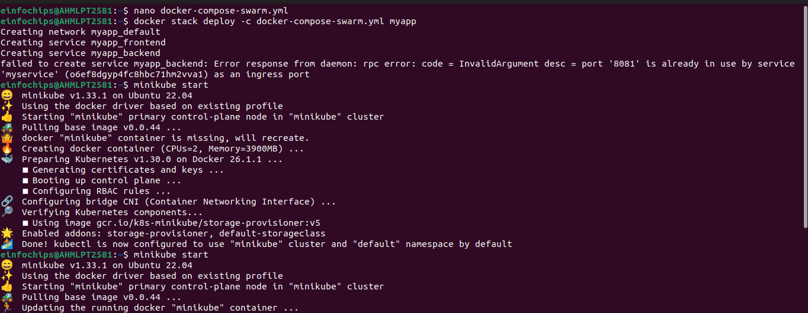

### **Step 2: Set up Kubernetes Using Minikube**

#### **2.1 Start Minikube**

# Start Minikube

minikube start

#### 

### **Step 4: Use a Single Shared Volume Across Multiple Containers**

Update docker-compose.yml as shown in Step 3.1 to use the shareddata volume across the frontend and backend services.